Dear Parents and Carers,
As a part of your child’s education at Fairway Primary Academy, we promote personal wellbeing and development through a comprehensive Personal, Social, Health and Economic (PSHE) education programme. PSHE education is the curriculum subject that gives children the knowledge, understanding, attitudes and practical skills to live safe, healthy, productive lives and meet their full potential.
PSHE education is taught throughout the school in every year group and is monitored and reviewed regularly by the staff and governing body. Please see our PSHE curriculum below for guidance. All PSHE teaching takes place in a safe learning environment and is underpinned by our school ethos and values.
I am writing to let you know that after May half term your child’s class will be taking part in lessons which will focus on the relationships and sex education (RSE) aspect of this programme.
Both Health and Relationships Education is statutory in Primary Education and you cannot withdraw your child from these lessons. Sex Education is defined as ‘Understanding Human Reproduction’ and you can withdraw your child from these lessons:
• Year 4, Changing Me, Lesson 2 (Having a baby)
• Year 5, Changing Me, Lesson 4 (Conception)
• Year 6, Changing Me, Lesson 3 (Conception, birth)
As a school community, we are committed to working in partnership with parents and over recent years the majority of parents continue to be highly supportive of the relationships and sex education programme. If you would like to find out more or discuss any concerns or you would like to request a withdrawal form, please speak to your child’s class teacher.

Yours sincerely,
Miss Connelly
(PSHE Lead)

Our PSHE/RSHE Curriculum Fairway Primary Academy:
At Fairway Primary Academy, we teach Personal, Social, Health and relationships Education as a whole-school approach to underpin children’s development as people and because we believe that this also supports their learning capacity.
The Jigsaw Programme offers us a comprehensive, carefully thought-through Scheme of Work which brings consistency and progression to our children’s learning in this vital curriculum area.
What do we teach when and who teaches it?
Jigsaw is a whole school approach that covers all areas of PSHE for the primary phase including statutory Relationships and Health Education. The table below gives the learning theme of each of the six Puzzles (units) and these are taught across the school; the learning deepens and broadens every year as children progress through the school.
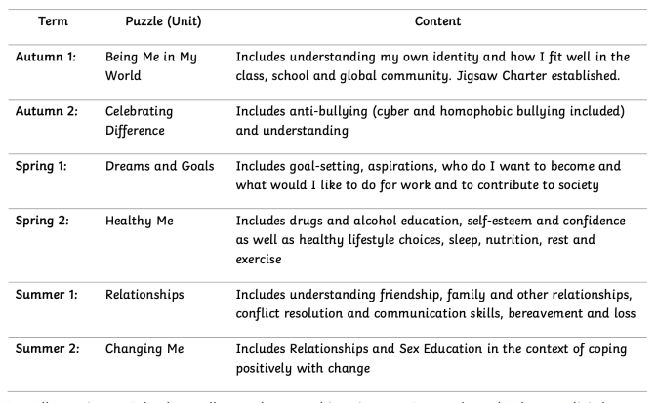
What is taught in Health and Relationships Education?
Both Health and Relationships Education is statutory in Primary Education and you cannot withdraw your child from these lessons.
Relationships Education in primary schools will cover ‘Families and people who care for me’, ‘Caring friendships’, ‘Respectful relationships’, ‘Online relationships’, and ‘Being safe’
Health Education in primary schools will cover ‘Mental wellbeing’, ‘Internet safety and harms’, Physical health and fitness’, Healthy eating’, ‘Drugs, alcohol and tobacco’, ‘Health and prevention’, ‘Basic First Aid’, ‘Changing adolescent body’
Sex Education at Fairway Primary Academy
The DfE Guidance 2019 (p.23) recommends that all primary schools ‘have a sex education programme tailored to the age and the physical and emotional maturity of the pupils. However, ‘Sex Education is not compulsory in primary schools’. (p. 23). Sex education ‘should ensure that both boys and girls are prepared for the changes that adolescence brings and – drawing on knowledge of the human life cycle set out in the national curriculum for science - how a baby is conceived and born’.
At Fairway Primary Academy, we define Sex Education as ‘Understanding Human Reproduction’. And believe children should understand the facts about human reproduction before they leave primary school so for this reason, we teach sex education embedded within our Jigsaw PSHE programme. We may use resources from other sources/programmes to support and enhance our Jigsaw programme.
Parents’ right to request their child be excused from Sex Education
“Parents have the right to request that their child be withdrawn from some or all of sex education delivered as part of statutory Relationships and Sex Education” DfE Guidance p.17
At Fairway Primary Academy, puberty is taught as a statutory requirement of Health Education and covered by our Jigsaw PSHE Programme in the ‘Changing Me’ Puzzle (unit). We conclude that sex education refers to understanding human reproduction, and therefore parents have a right to request their child be withdrawn from the PSHE lessons that explicitly teach this (The Jigsaw Changing Me Puzzle Unit in summer term 2)
- Year 4, Changing Me, Lesson 2 (Having a baby)
- Year 5, Changing Me, Lesson 4 (Conception)
- Year 6, Changing Me, Lesson 3 (Conception, birth)

If you wish to withdraw your child from the lessons stated above, please request a withdrawal form from your child’s class teacher.

Parent form: withdrawal from sex education within RSE

TO BE COMPLETED BY PARENTS
Name of child |  | Class
Name of parent / carer |  | Date
Reason for withdrawing from sex education within relationships and sex education
Any other information you would like the academy to consider
Parent / Carer signature

